Project Design Phase-II Technology Stack (Architecture & Stack)

|  |  |
| --- | --- |
| Date | 03 October 2022 |
| Team ID | PNT2022TMID42318 |
| Project Name | Project - Real-Time River Water Quality Monitoring and Control System |
| Maximum Marks | 4 Marks |

# Technical Architecture:

The Deliverable shall include the architectural diagram as below and the information as per the table1 & table 2

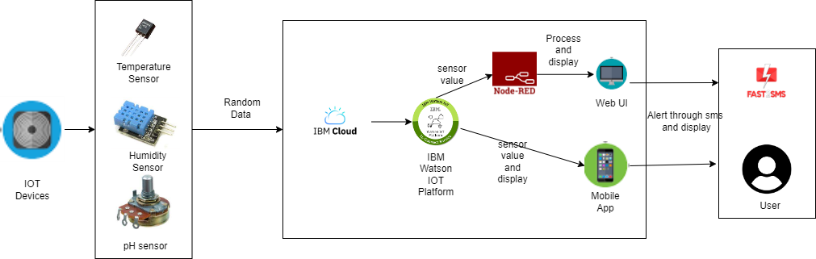

# Table-1 : Components & Technologies:

|  |  |  |  |
| --- | --- | --- | --- |
| **S.No** | **Component** | **Description** | **Technology** |
| 1. | User Interface | Web UI, Mobile App | Node – Red, Kubernetes, MIT mobile app inventor |
| 2. | Application Logic-1 | Generate random data | Python |
| 3. | Application Logic-2 | Generate random sensor data | IBM Watson IOT Platform |
| 4. | Cloud Database | Database Service on Cloud | IBM DB2, IBM Cloudant, |
| 5. | External API-1 | Send SMS to customer | Fast SMS API |
| 6. | Infrastructure (Server / Cloud) | Application Deployment on Cloud | Cloud Foundry, Kubernetes |

**Table-2: Application Characteristics:**

|  |  |  |  |
| --- | --- | --- | --- |
| **S.No** | **Characteristics** | **Description** | **Technology** |
| 1. | Open-Source Frameworks | open-source frameworks used to develop our project | Node – Red, IBM Cloudant, IBM Watson IOT Platform |
| 2. | Security Implementations | Use of Login facility with username and password for individual user | Password protection in MIT App |
| 3. | Scalable Architecture | Web Ui designed for use in Mobile and computer  with adaptive screen size | Node – Red (Web UI) |
| 4. | Availability | Available for the user in both web UI and Mobile App | Node – Red(Web UI), MIT App(Mobile App) |
| 5. | Performance | Give accurate results and immediate alert in case of contamination of water | Node – Red(Web UI), MIT App(Mobile App) |